1.Creating Ec2 instances with t2.Medium
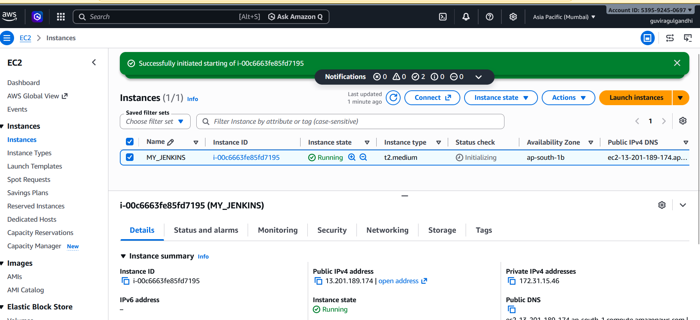
2.Installing Jenkins on the Machine
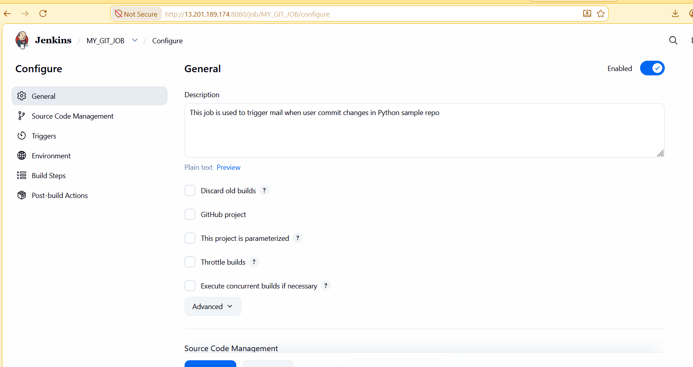
3.Freestyle project configuration and Trigger set to GIT SCM:
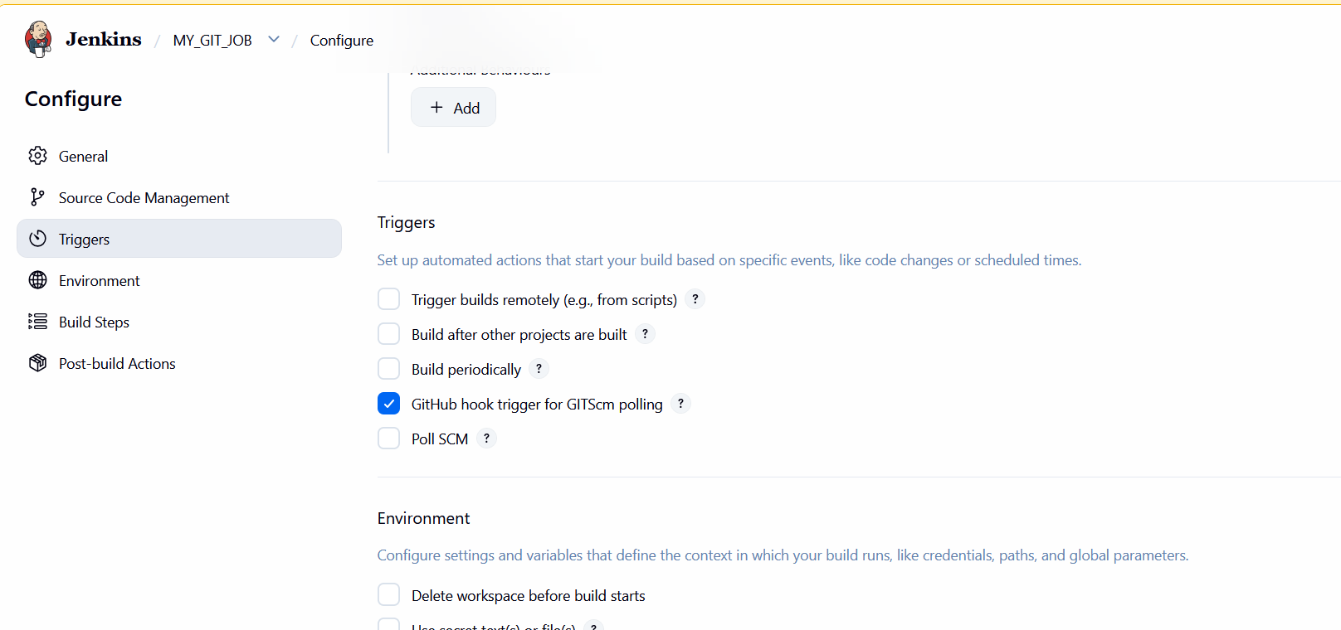
4.Post Build action with Editable Email notification with Trigger as always in the Job.

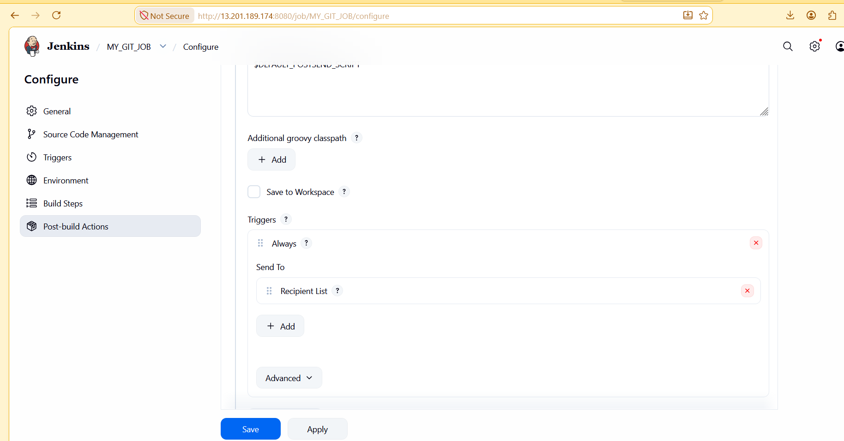
5.Personal email given as sys admin for the mail.
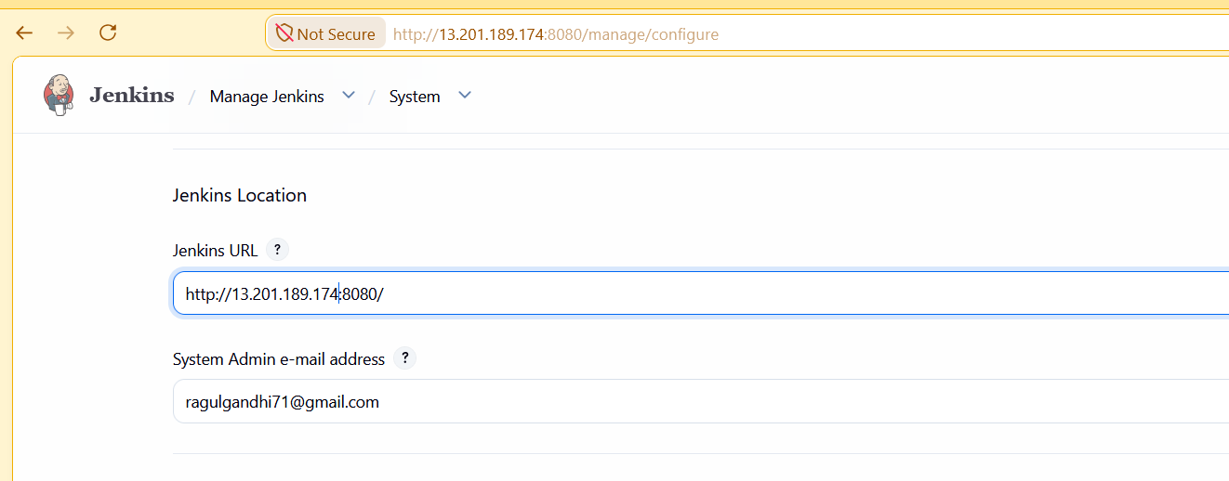
6.Extended Email notification configuration with Gmail app passwords.

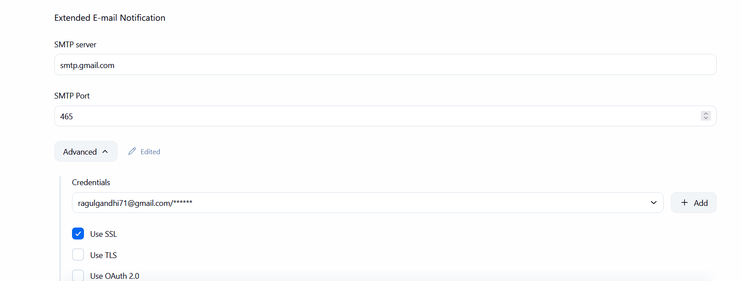

7.Adding Webhook for the GIT repo.
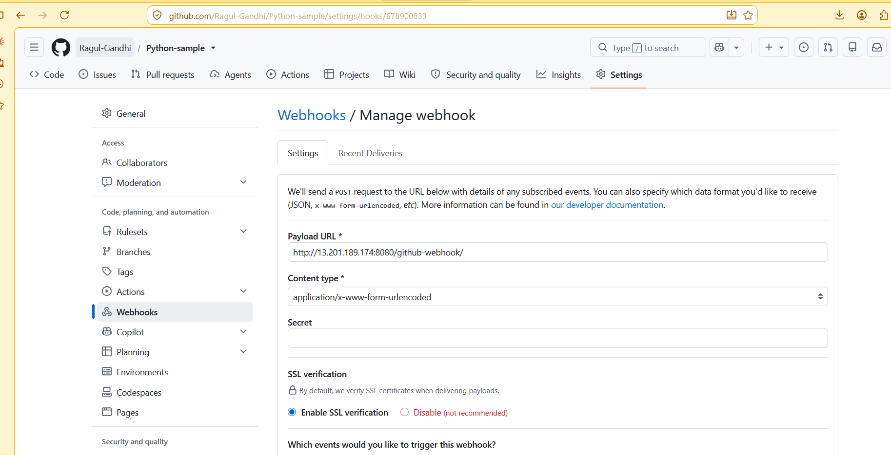

8.GIT Commit changes on the repo.
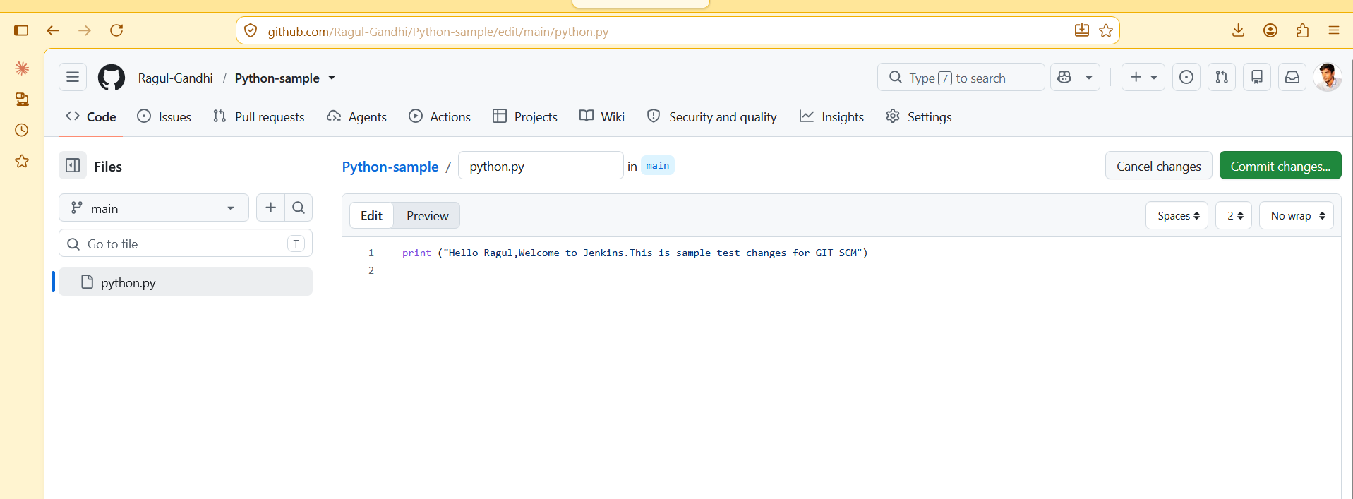
9Job Running success with GIT Push.

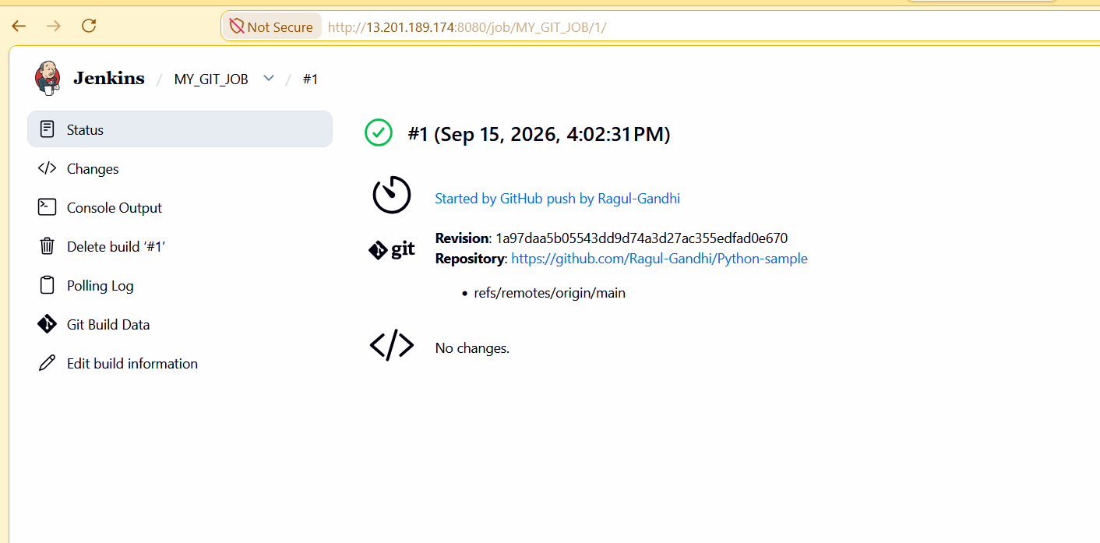10.Console Log verification for the GIT SCM.
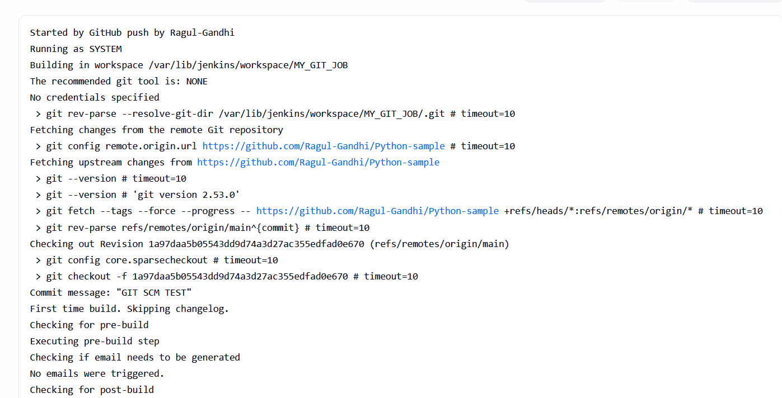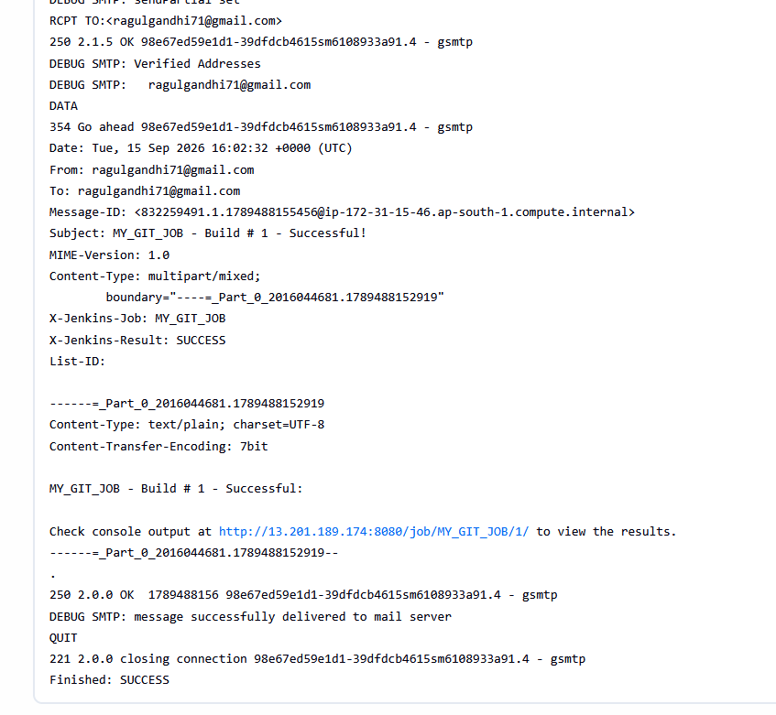11.Mail trigger for the GIT Push through Jenkins.


